**LAB: 12**

Q.1 Write a program to pass an array of numbers to a function and calculate its sum of all elements

**Program**

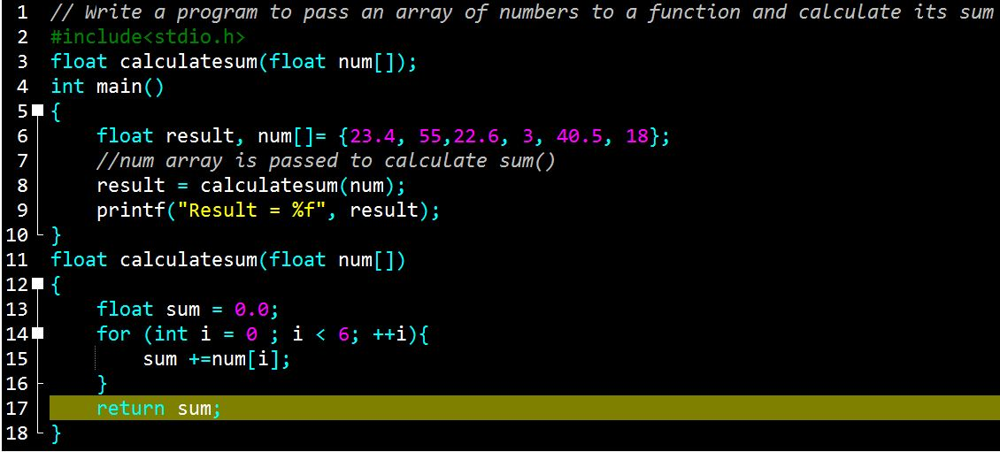

**Output**

